Amazon Web Services
Elastic Compute Cloud (EC2)
EC2 (Elastic Compute Cloud) is a cloud service by AWS that provides virtual computers called instances. We can use these instances to run applications, websites, or servers without needing physical hardware. It is scalable, pay-as-you-go, and allows us to choose CPU, RAM, storage, and operating system based on our needs.

Screenshot1 – Launched Instance
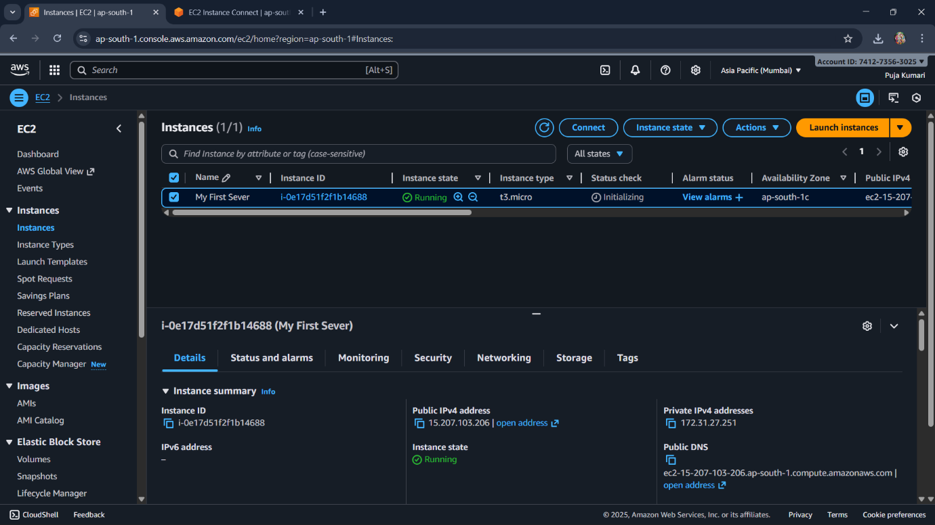

Explaination:
- The screenshot shows the AWS EC2 Instances page in the Mumbai (ap-south-1) region.
- An instance named “My First Sever” is Running with type t3.micro.
- The instance details show its Public IPv4 address, Private IP, and Public DNS for connecting.
- The left sidebar displays EC2 options such as Instances, AMIs, Volumes, and Security settings.

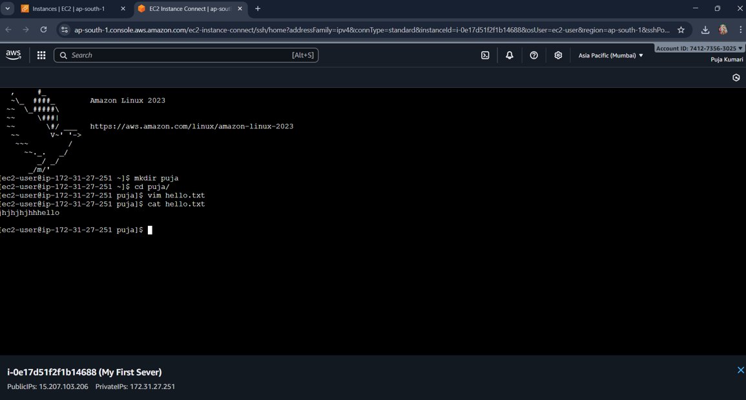
Screenshot2 - EC2 Instance Terminal View
Explaination:-
- The screenshot shows inside our AWS EC2 Instance using EC2 Instance Connect (browser-based SSH).
- We created a new folder named puja, moved into it, and created a file called hello.txt using vim.
- The file contains some text, which we displayed using the cat hello.txt command.
- The terminal confirms we are logged in as the ec2-user on an Amazon Linux 2023 server.

Screeenshot3 - Key Pairs
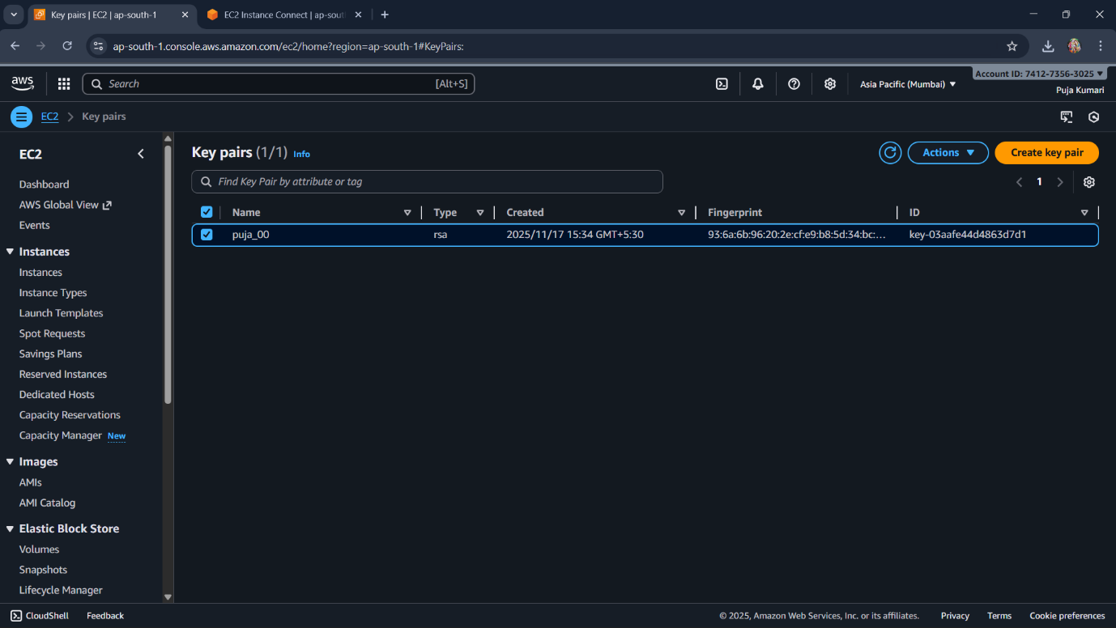
Explaination:-
- This screen shows the Key Pairs section of AWS EC2 in the Mumbai region.
- We have one key pair named puja_00, created with the RSA encryption type.
- Key pairs are used to securely connect to EC2 instances via SSH.
- The fingerprint and key ID uniquely identify this key pair in our AWS account.

Screenshot4 - Security Groups
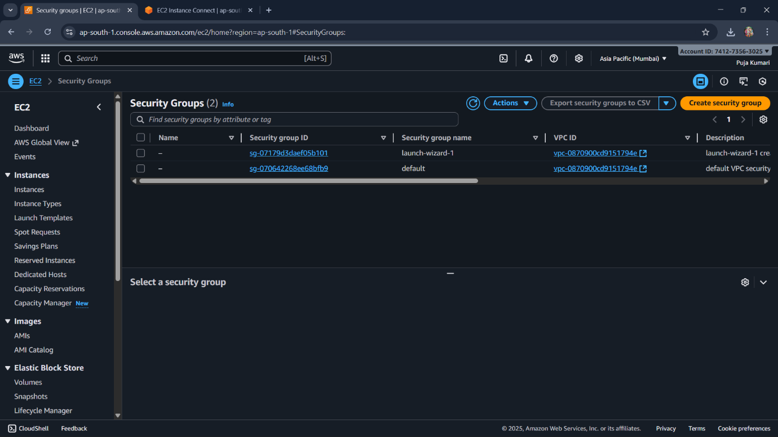
Explaination:-
- This screen shows our Security Groups list inside EC2.
- We have two security groups: launch-wizard-1 and the default group.
- Security groups act as virtual firewalls, controlling which traffic can enter or leave your instance.
- Each security group belongs to a specific VPC, shown in the VPC ID column.

